Walk for the Wild information Sheet:
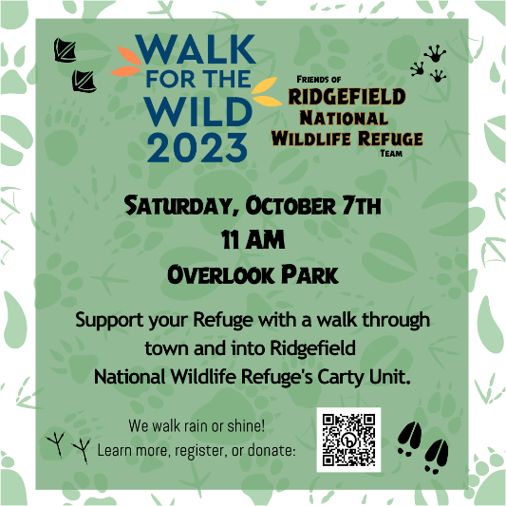
We're on a mission to empower wildlife and humans to thrive. The challenge is to get people moving a distance of 5K in nature and to raise funds to support the future Community Nature Center at Ridgefield National Wildlife Refuge.

What is 'Walk for the Wild'?
Walk for the Wild is a national event to get people moving in support of their local national wildlife refuge. Funds raised from this event will directly support wildlife conservation, nature trails, and environmental education in our community through a new Community Nature Center.
Sign up to walk today and support the National Wildlife Refuge System. If you donate, a portion of your donation will be matched by national supporters of Walk for the Wild and the Public Lands Alliance.

When: Saturday, October 7, 2023, 11:00 AM
Where: Overlook Park to Ridgefield National Wildlife Refuge's Carty Unit
We will be offering a kick-off walk during BirdFest & Bluegrass, Saturday, October 7, starting at Overlook Park- on a fall Pacific Northwest morning- who could ask for more?
If you can't make the group walk on Saturday, you can get your miles in any time during National Wildlife Refuge Week, October 7-14, and submit them to support our team.

To get started: Click “Join Our Team” to learn more, sign up to participate in our event and/or walk virtually, or donate: https://support.americaswildliferefuges.org/team/516152

